l.
Ballynure Primary School
Newsletter

Website Ballynureps.org

30th March 2023

Dear Parent/Carer,

IMPORTANT DATES
Easter Holidays- Monday 3rd – Friday 14th April. Please note school will close at 12noon tomorrow and there will be no school meals and no school bus.

AFTER- SCHOOL CLUBS
After school’s clubs will continue as they were from 17th April.

SWIMMING TERM 3
Swimming will commence for P6 from Monday 17th April; the cost is £2.80 per week, please send the correct money with your child each Monday.

SCHOOL PHOTOGRAPHER
Our school photographer will be in school on Wednesday 26th April, all children should be in their normal school uniform. The photographer will be taking group photos of our P1 & P7 classes as well as individual photos for these year groups and sibling photographs for all families. The photographer will also take any other individual photos by advance order, if you wish your child to have an individual photograph, please email Mrs Millar by Friday 21st April. We would also like to invite any younger siblings who aren’t of school age to Ballynure Primary on the morning of Wednesday 26th April to have their photograph taken with their sibling/s. Again, should you wish to avail of this opportunity please email Mrs Millar before Friday 21st April.

MIGHTY MILE
Our mighty mile annual sponsored event will take place on Wednesday 19th April. Please wear trainers and tracksuits or leggings and sports top to school Monday – Wednesday. On Wednesday children should bring a full waterbottle, a packed lunch and a rug to sit on in the playground. Free school meals will be available to book in the usual way and will comprise of a packed lunch, alternatively children can bring their own packed lunch as normal.

A sponsor form has previously been sent home in the children’s school bags all monies and completed forms must be returned to school no later than Friday 28th April. All children will be given a medal for taking part. Children should bring £1.00 to their class teacher by Monday 17th April . This year we are raising money for our reading resources for the whole school. Thank you in advance for your support.

KING’S CORONATION ROBE PROJECT
We were inundated with amazing designs from our P4-P7 pupils for the King’s Coronation robe – well done everyone! There were so many wonderful ideas that we selected many of your symbols to sew a collaborative square. If your drawing included: a crown, CR III , a tractor, a bee, trees, fields or our school name it has been represented. A huge thank you goes to Mrs Kelly who undertook the sewing. I’m sure you’ll agree she made an excellent job of it.
We think it looks very special and is befitting of our school and the King’s Coronation. The squares from schools in the borough are to be sewn together to make a robe which will be unveiled the day before the coronation and displayed in civic buildings. Please look on our website to see the photographs.

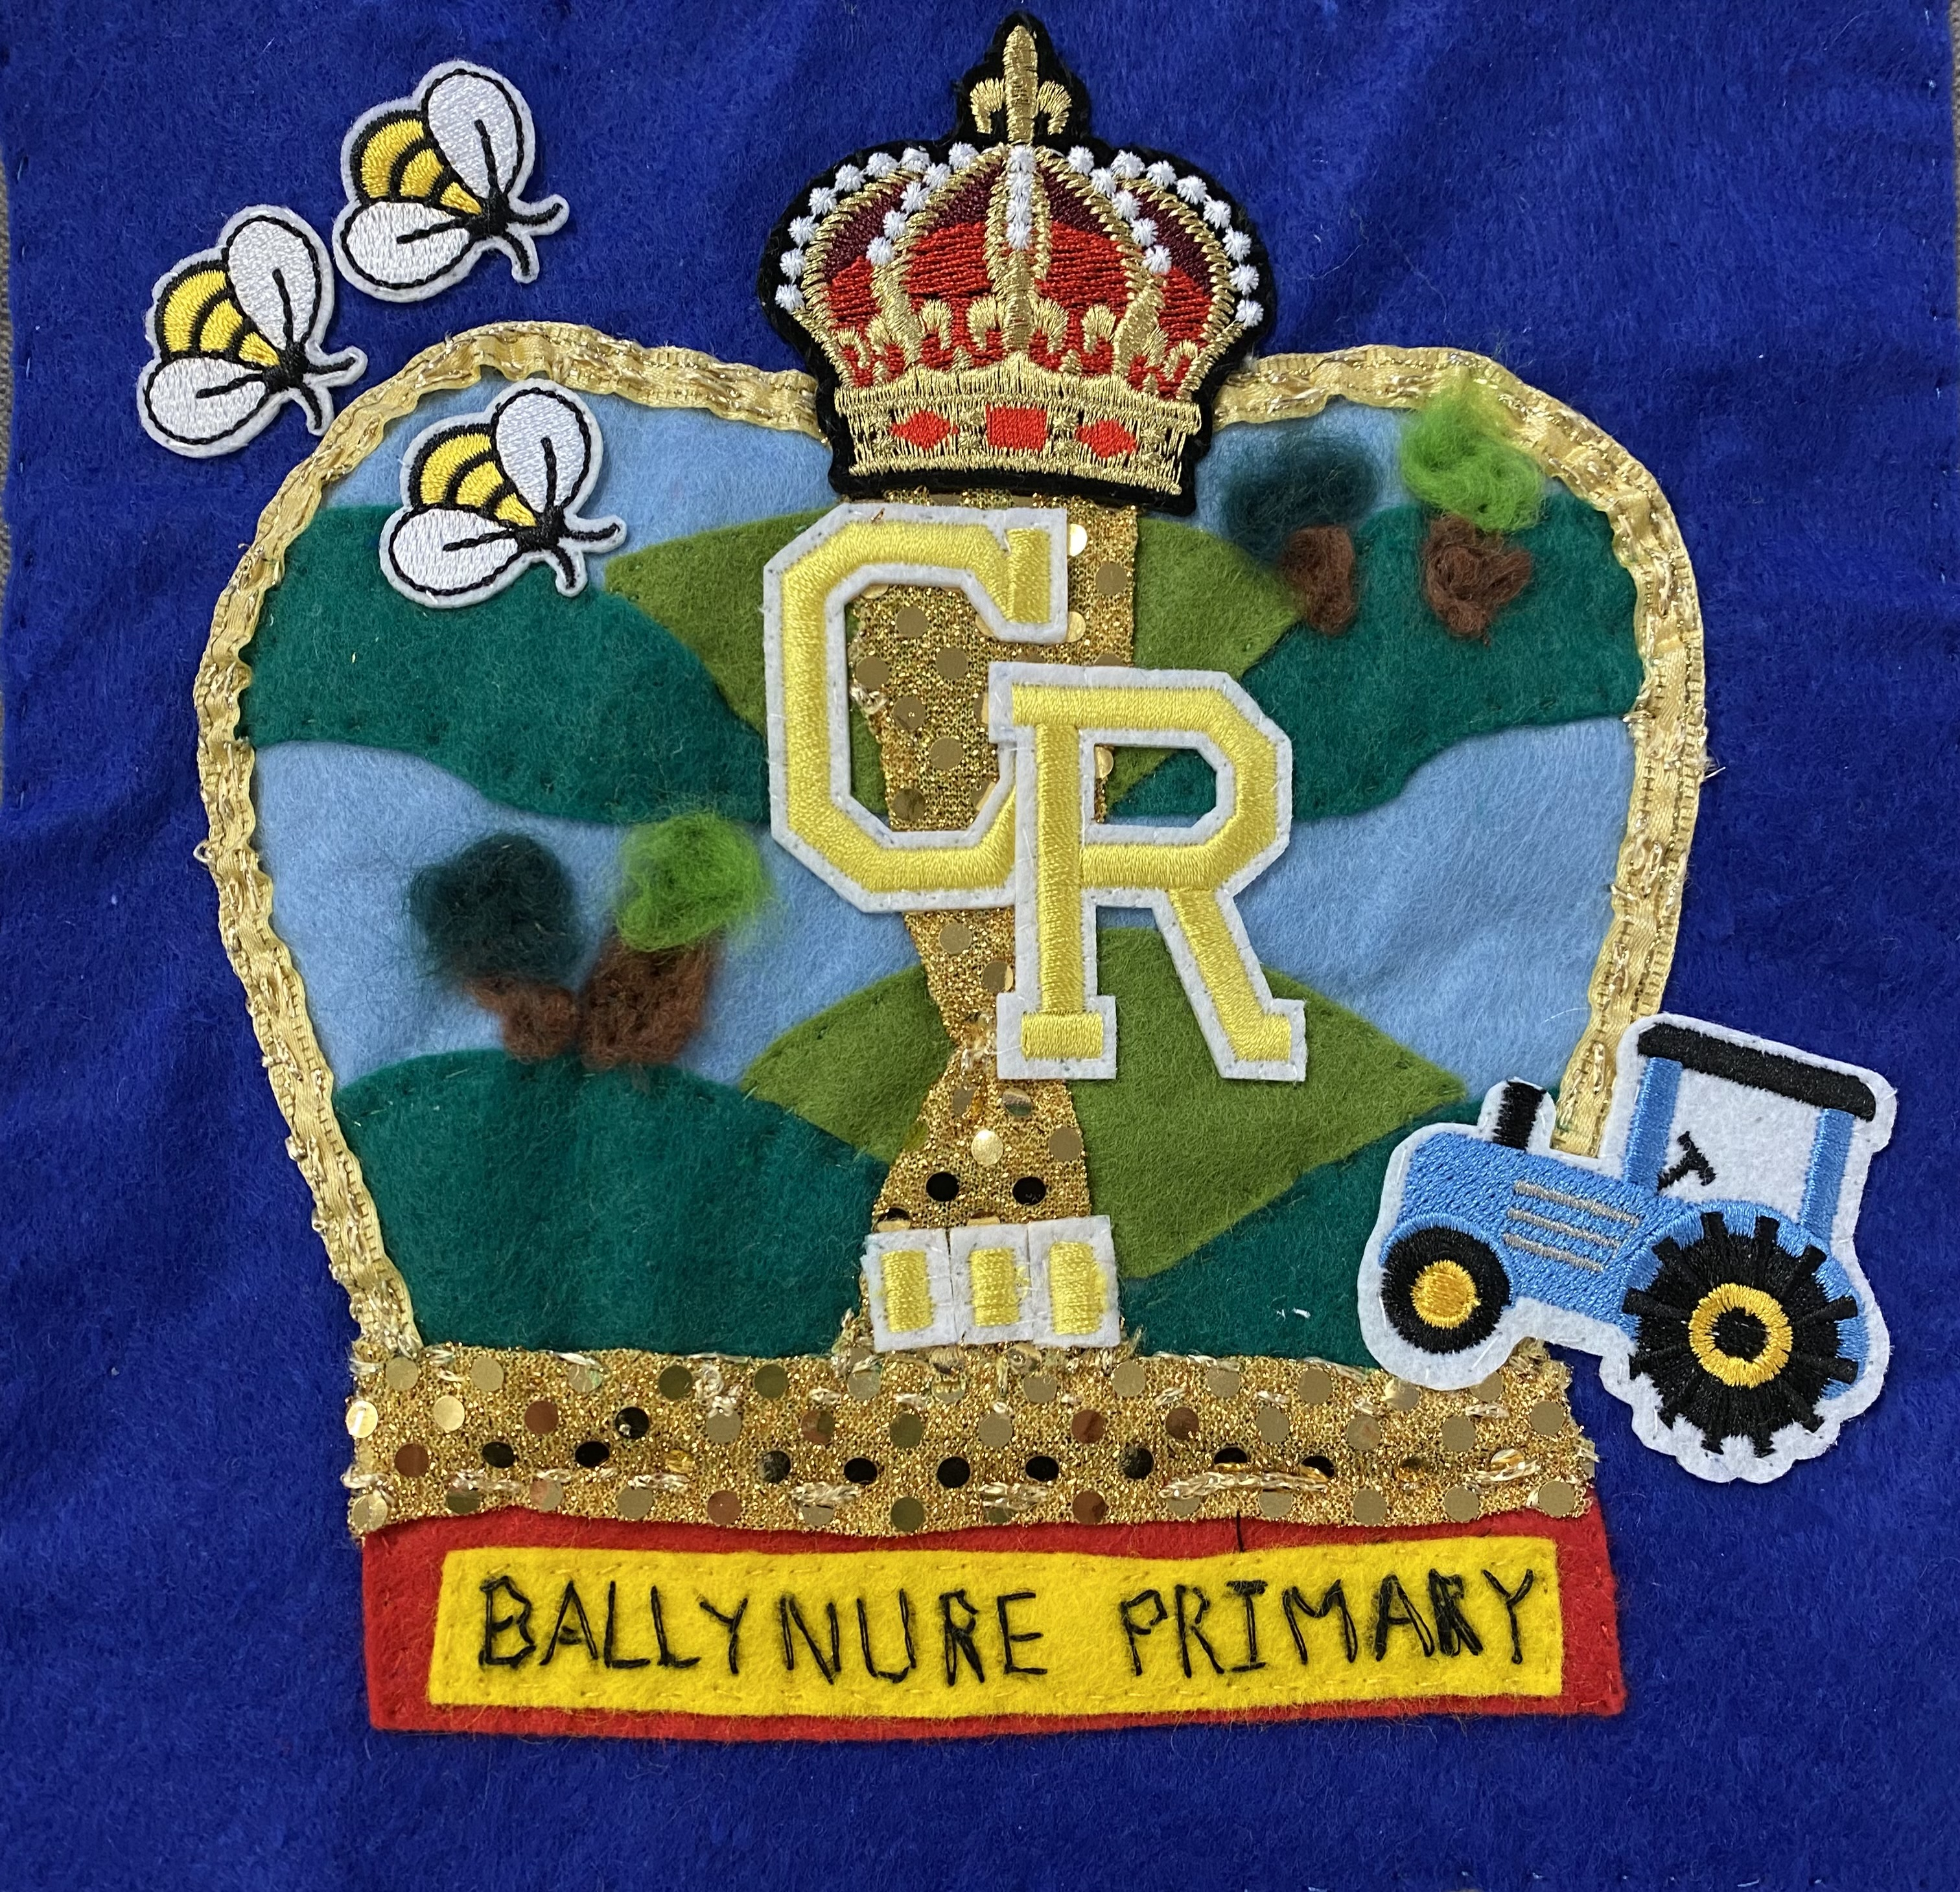

PE UNIFORM
All PE Uniform orders should now be in. If you have any last-minute orders, please send these in by 10am tomorrow morning.

EASTER EGG HUNT
On Tuesday Ballynure Playgroup and all of Ballynure Primary went on an Easter Egg Hunt in our school grounds. All the children had a fantastic time. Thank you to Ballynure Spar and Ballynure Co-Op who sponsored our Easter treats for the event.

GIRL’S HOCKEY TEAM
On Wednesday, Mrs McClean took two teams to the Carrick hockey tournament. The girls played very well during the seven matches in total. They won five, drew one and lost one. A great afternoon was had by all and many thanks to those who came down to support.

SUPPLY REPLENISH
For the new term we would ask that all children P1-P7 bring in a packet of wipes or tissues to replenish class supplies.
P1 please send 2 glue sticks per child.
P2- P7 please ensure all items from your child’s pencil case are replenished for the new term including glue sticks. All children P4-P7 also require a 30cm ruler.

BOARD GAME APPEAL
If you have any unwanted board games with all their pieces, please consider donating them to school. For example:

-Orchard toy games
- Draughts
-Chess
-Snakes and Ladders
-Dobble
-Top Trumps
-Connect 4
-Guess Who
-Uno
-Snap

E Doherty R Woods
Principal Principal

COMMUNITY NEWS

Larne Rugby Club are running their annual girls give it a try programme for girls aged 8-14 from Tuesday 18th April 6.30- 7.30pm. For further information contact Judith Taylor on 07786 707 803

The School has no means of endorsing the activities or events in Community News.
Parents are advised to ensure any activity is appropriate for their child.

Monday 17t^{h} April
For further information on allergenic ingredients, please contact the school.

SCHOOL MEALS
WEEK 3

Monday | Tuesday | Wednesday | Thursday | Friday
Oven Baked Pork Sausages  Chipped/Baked Potato  Baked Beans  Ice-Cream & Pears with Hot Chocolate Sauce | Pepperoni Pizza Slice  Diced Potato  Coleslaw  Zesty Orange Sponge & Custard | Mighty Mile –  Packed lunch  Any free school meals requiring a lunch can order in the usual way. | Roast Gammon with Stuffing & Gravy  Mash &Oven Roast Potatoes  Baton Carrots & Fresh Cabbage  Decorated Iced Sponge Finger | Oven Baked Breaded Fish  Chipped/Baked Potatoes  Salad/Baked Beans  Strawberry Milkshake & Flakemeal Biscuit

